* **Job Type Master File**

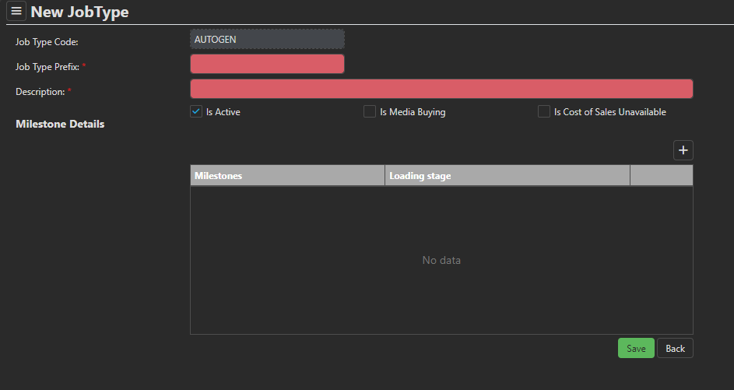

* Job type master file is used to categorize the jobs and tasks.
* **Job type code** is auto generated from the system. Prefix : JT, Format : JT/0001
* **Description** is manual entry by user.
* **Job Prefix:** Include 2 character prefix, which is a mandatory field. This prefix will be used in the Job creation entry to generate the Job reference number. Prefix cannot duplicate (Needs to be checked in New/Edit)
* By default, the **active** checkbox is checked. If the job type becomes inactive, the checkbox is unchecked
* Users can allocate standard **milestones**, which are common for each job type.
* **Loading stage** is a dropdown list with ‘stage 1’ and ‘stage 2’. This field is used to populate the milestones before and after client approval for a job in the traffic controller operation.